YEAR 11 PHYSICS: Heat Unit Test. Name: _________________________________
(33 marks total)
Written Section.
Where appropriate, all written answers are to include the name and explanation of the physics law or phenomena illustrated in the question.

- Students in year 9 often say that heat is how hot something is. Imaging you are teaching a year 9 class, explain to them the difference between heat and temperature. They have already studied energy in general and understand the terms potential and kinetic energy. (2 marks)

____________________________________________________________________________________________________________________________________________________________________________________________________________________________________________________________________________________________________________________________________________________________________________________________________________________________________________________________________________________________________________________________________________________________________________________________________________
- While Samantha was rugged up on a cold night, she noticed that her cat’s fur seemed very fluffy. Explain why the fluffy fur would help keep the cat warm. (3 marks)

________________________________________________________________________________________________________________________________________________________________________________________________________________________________________________________________________________________________________________________________________________________________________________________________________________________________________________________________________________________________________________________________________________________________________________________________________________________________________________________________________________________________
- Matthew and Veronica are looking for floor covering. Matthew feels a tiled floor and finds it too cold. Veronica feels the carpeted floor and finds it warm. When they discuss this with the salesman, he correctly informs them that the two coverings are the same temperature. If the two coverings are the same temperature, why does the tiled floor feel cold while the carpet feels warm? (3 marks)

___________________________________________________________________________________
___________________________________________________________________________________
___________________________________________________________________________________
___________________________________________________________________________________
___________________________________________________________________________________
___________________________________________________________________________________
___________________________________________________________________________________
___________________________________________________________________________________
___________________________________________________________________________________
- 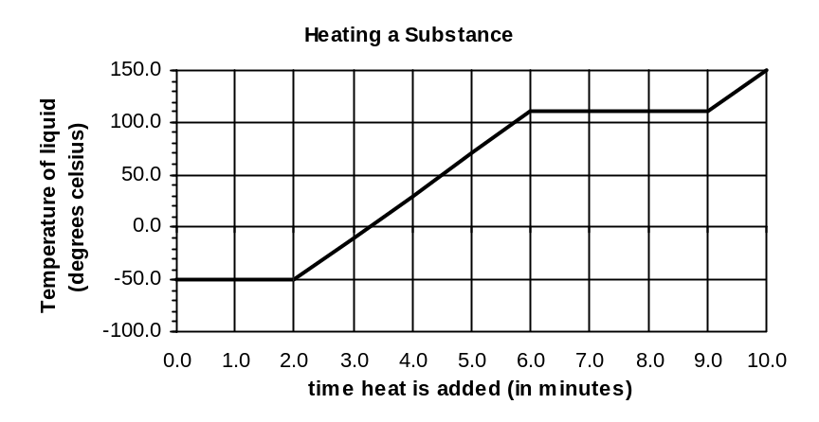A student using a bunsen burner, a thermometer, a clock and a substance in a beaker, does an experiment to obtain the following graph.

a. What phase or phases is/are present between
(i) B and C? _____________________________________ (1 mark)
(ii) C and D? _____________________________________ (1 mark)
- Explain on a molecular level why the temperature doesn’t change between C and D although heat is still being added to the substance. (2 marks)

________________________________________________________________________________
________________________________________________________________________________
________________________________________________________________________________
________________________________________________________________________________
________________________________________________________________________________
________________________________________________________________________________
- Explain why section AB is shorter than section CD. (2 marks)
______________________________________________________________________________________________________________________________________________________________________________________________________________________________________________________________________________________________________________________________________________________________________________________________________________________________________________________________________________________________________
Calculation Section:

- Calculate the heat energy required to heat 0.150 kg milk (specific heat 3.90 x 10³ Jkg⁻¹K⁻¹) from 8.00⁰C to 75.0⁰C? (2 marks)

- The graph below shows the heating curve for 0.600 kg of a solid which has been heated in a well-insulated container by a 1.00 x 10² W heater. Calculate the specific heat of the substance in its liquid phase. (3 marks)
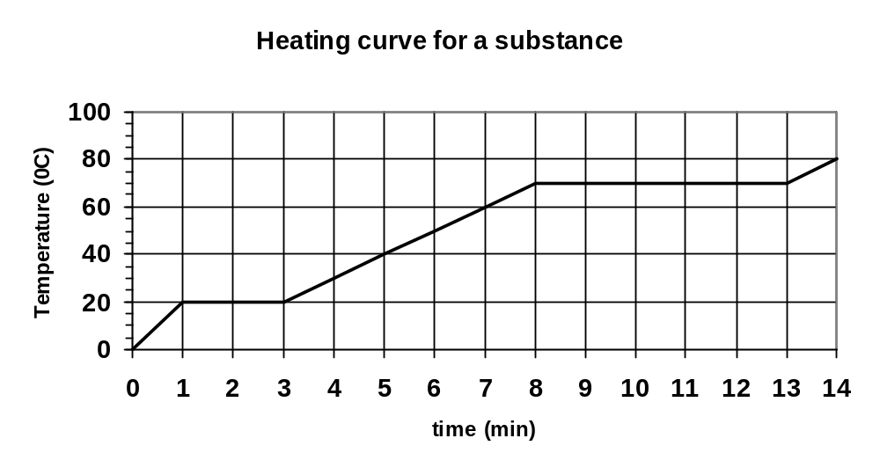

- 7.83 x 10⁵ J of heat energy is applied to ice at 0.00⁰C. How much of the ice would melt? (2 marks)

- 0.200 kg of steam at 108.0⁰C has heat energy removed until it becomes ice at –5.00⁰C. Calculate the amount of heat energy removed. (3 marks)

- You are catering for a party. If you had a suitable source which could provide you with 5.00 MJ of heat energy, as well as an unlimited supply of water at room temperature (20.0⁰C), teabags, cups (to hold 200.0 mL of tea), teaspoons, etc., how many cups of tea could you make for the party. Assume no loss of energy to the surroundings, that the water must just boil before you make the tea and that the specific heat of the tea is the same as water. (3 marks)

- An ice-block tray holding 0.250 kg of water at 18.0⁰C is placed in the freezing compartment of a refrigerator. If it takes 1.50 hours to form ice-blocks (at 0.00⁰C), at what rate (in Js⁻¹) was the refrigerator extracting heat from the water? (3 marks)

- A students adds ice at –5.00⁰C to 200.0 mL of water at 80.0⁰C which is in an insulated 55.0 g copper calorimeter (specific heat 380.0 Jkg⁻¹K⁻¹). After the ice has all melted, the student takes the temperature and finds that it is 25.0⁰C. How much ice did the student add? Assume no heat loss to the surrounding air. (3 marks)

